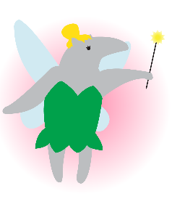

Presenting…  
**Circle K International**

**at UC Irvine**

2012 Fall Quarter, Wk 2

Tuesday, October 9, 2012

www.ucicirclek.org

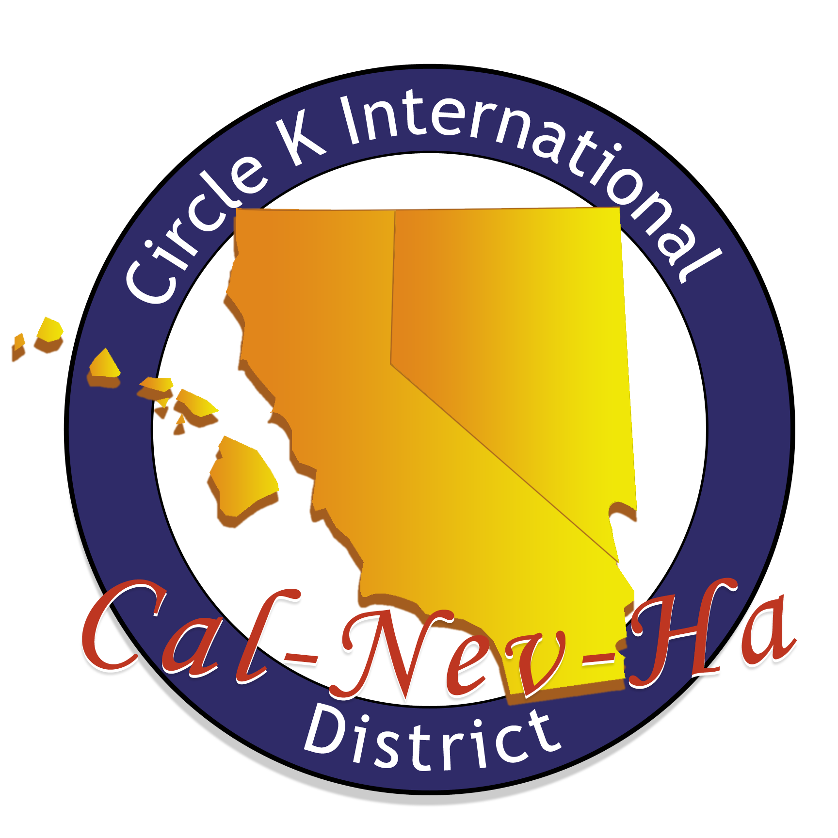



## October 2012

|  |  |  |  |  |  |  |  |
| --- | --- | --- | --- | --- | --- | --- | --- |
|  | TUES. Oct. 9 | WED. Oct. 10 | THURS. Oct 11 | FRI. Oct 12 | SAT. Oct. 13 | SUN. Oct 14 | MON. Oct. 15 |
| SERVICE |  | -**Working Wardrobe** @2:50-5pm | -**Book Doctor** @ 3:30-5:30pm | -**Hemopet** @ 8:30-11am  -**Shocktoberfest Fundraiser** @ 5:30pm | -**Pugs N' Pals** @ 6:30-11am  -**Key Club RTC** @ 10:30am-5pm  -**Pugs N' Pals** @2:30-7pm | **-2nd Sundays** @ 8:30am-12pm |  |
| LEADERSHIP | -**Irvine Kiwanis** @ 7-9am  -**Whittier CKI Mtg** @ 3:15pm  -**OCC CKI Mtg** @ 4pm  -**UCI CKI Mtg @** 6pm | -**DISTRICT:**  **FTC** FEES DUE: $70  -**DISTRICT: CKI SOUTH** FEES DUE: $6  -**SAC CKI Mtg** @ 3:30pm  -**Scrapbook Mtg** @ 6-7pm in West Food Court  -**CKI 101Workshop:**  @ 7-8pm in SSL 145  -**FTC Skit Filming** @ 8-9:30pm | **-CDM Kiwanis Mtg** @ 11:30am-1:50pm  -**FV Kiwanis Mtg** @ 11:45am-1:30pm  -**IVC CKI Mtg** @ 2:30pm  -**Saddleback CKI Mtg** @ 2:50pm  -**CSUF CKI Mtg** @ 5pm  -**Tech Mtg** @6pm in HH 224 | -**Lake Forest Kiwanis Mtg** @ 6:40-9am |  | **-MRP Committee Mtg** @ 5-6pm in Emerald Bay DE  -**Board Meeting** @6pm in Newport Beach A | **-Member App DUE for Member INduction**  **-Saddleback Kiwanis** **Mtg** @ 11am-2:15pm  -**Fundraising Committee Mtg**  @ 5-6pm in SSL 228  **-Single/Service Committee Mtg**  @ 6-7pm in SSL 228 |
| FELLOWSHIP | **-Zot Zone Social** @ 8pm | **-Coffee Time w/ Sarina** @ 11-1pm |  |  |  | -**Volleyball Social** @ 3-4pm in Arc  -**America’s Funniest Home Videos Social** @ 7:30pm in Berkeley Ct. Clubhouse | -**Co-Ed Volleyball I.M.s**@ 7:30pm in ARC |

**UPCOMING**

**EVENTS**

**UCI EVENTS:** MEMBER INDUCTION – 10/16 || WEEK OF SERVICE – 10/16-10/22

**DIVISIONAL EVENT:** October DCM 10/21 [at CKI South]

**DISTRICT EVENTS**: CKI SOUTH – 10/21 || FALL TRAINING CONFERENCE (FTC) – 11/2-11/4

Week 3 & 4: RH 104

Week 5 & 6: Doheny Beach A  
Week 7: Pacific Ballroom C

Week 8: Pacific Ballroom D

Week 9: RH 104

**Website:** www.ucicirclek.org  
**Facebook:** http://www.facebook.com/groups/242970149059638/  
**Tumblr:** http://ucicki.tumblr.com/  
**Flickr:** http://www.flickr.com/photos/ucicirclek  
**Newsletter:** http://issuu.com/adrianfrancisco

**GET CONNECTED**

**Gen. Mtg Locations**

**REMINDERS**

1. **Member Application?** Ask a board member or download one from our website: [www.ucicirclek.org](http://www.ucicirclek.org)
2. To be a part of **Member Induction**, Apps. are **DUE BY OCT. 15th!!!**
3. **EARLY REGISTRATION FOR CKI SOUTH ($6) + FTC ($70) DUE OCT. 10!!!**
4. **Drop off Dues/App.** during Gen. Mtg, to any board member, or at Phoenix Grill Tues-Thurs @ 2-3pm to Elmore, Treasurer.
5. Click on an event you like on the calendar and **sign up online to attend**: <http://clubs.uci.edu/circlek/SSB_calendar.php>
6. **Need a ride to an event?!?!** Meet at the flagpoles for ALL events!
7. **Want to chair an event?** Add your name and number on our Chair Doc: <https://docs.google.com/spreadsheet/ccc?key=0AnKaL6lqusFSdFhvbWNYNklING42UEpNSHVCTk9CZ1E&authkey=CICZjZED&authkey=CICZjZED>
8. **Want to Submit an Article for “The Second Star?”** Contact our Bulletin Chair, Adrian Francisco!

**Agenda**

1. **Call to Order – Sarina Saldana, President**
2. **Introduction of Guests – Sarina Saldana, President**
3. **Upcoming Service Events – Amy Hoang**
4. **Bulletin – Adrian Francisco**
5. **Fundraising – Connie Phan & Ryan Leung**
6. **K-Family – John Delshadi & Samia Chowdhury**
7. **MD&E – Liz Ly**
8. **Shoutout Box – Adrian Franciso**
9. **MRP – Tanya Luu**
10. **PR – Charmaine Deomampo & Nathan Magoto**
11. **Scrapbook – Kevin Lam**
12. **Single Service – Michelle Ha & Samantha Ho**
13. **Spirit/Social – Lany Dao & Sam Barke**
14. **Technology – Brian Chew**
15. **VPA – Mayra Escobar**
16. **Treasurer – Elmore Villaruel**
17. **Secretary – Karen Truong**
18. **President – Sarina Saldana**
19. **Meeting Adjourned – Sarina Saldana, President**

